RESEARCH PROPOSAL
THE SECOND AMENDMENT AND THE EFFECTS IT HAS ON REGULATED GUN 0CONTROL
MIKALA PELZER
SSC 450.01
September 26,2020

INTRODUCTION
Introduction
The notion of stricter laws on gun control among American citizens has been on the rise over the recent years. Conversely, a good number of the citizens have the perspective that gun possession and militia should be necessary. On the other hand, there are those who are of different idea and feel that the issue of security should be addressed by the government and do not feel safe with the militia and gun possession by the public and advocates on stricter gun control laws. With this research, I intend to add salt on a fresh cut by comparing the two perspectives on militia and gun legislation policies to bring awareness and at the same time comprehension of stricter laws on gun control effects.
Background and Problem Statement
America has always had a very brutal conversation about the second amendment and gun control laws. This goes back to the 10th century before the United States claimed independence from the United Kingdom (U.K.) (Hodgson, 2017). If an organized rebellion was to occur in the U.K. then the supporters of the U.K. would fight against the rebellion (Hodgson, 2017). Once America became an independent country, the American people that lived here thought that having a well-regulated militia would provide security for the growing country. Without a full national army, the government needed a way to protect itself and fight off other counties, and this was when the guns came in play (Hodgson, 2017). The Second Amendment gives American citizens the option to possess a firearm. When the constitution was ratified, it was meant for each state to have its own form of protection to serve as the militia. The term militia means a body of citizens that have joined the military service, but they will only to be used in a time of. The reason why the American citizens wanted to keep guns were so they can protect their land from invasions. If the citizens of the United States did not want to keep the guns or if they had stricter rules and regulations for them in time, then we would not have to have in-depth conversations about gun control.
The problem that is going on in America is that we need to have stricter gun laws and stricter background checks. President Trump has stated that we needed to have stricter background checks on firearms but then seized the idea (Yoo, 2019). In July and August of 2019, there were three significant shootings that took place in El Paso, Texas, Dayton, Ohio and Gilroy, California (Yoo, 2019). Numerous people were killed and hurt due to these mass shooting. It is simple for individuals to get firearms in America. In the event that they get denied for getting a firearm license, at that point, the individuals would go to the underground market to go buy these weapons. My conviction is that there ought to be more guidelines going forward for firearms and background checks.
Purpose and Importance of the Research
The motivation behind this quantitative examination is to bring awareness to the circumstance and comprehend the effect of stricter gun control laws and background checks in America. This research shall explain why it is essential for us to consider having stricter gun laws because people who do not need to carry firearms have access to them. Those individuals are the intellectually sick, individuals who were discharged from detainment and individuals who are utilizing weapons for vicious reasons. The goal is to get elected officials to think about the significance of adjusting the gun laws in America. Changing gun laws could reduce the harm to those who are innocent bystanders such as the recent killing of the 8-year-old girl Secoriea Turner.
According to Gramlich and Schaeffer, 2019, there has been an increase in murders that included the use of guns since the 1990s. There is a large number of children that are dying from these issues, which are causing emotional and psychological damage or stress due to their cherished loved one passing away due to a firearm. This exploration is critical on the grounds that 40,000 individuals in 2017 have died because of gun violence (Gramlich and Schaeffer, 2019). In 2017, 52% of Americans said there should be stricter firearm laws; in 2019, the number increased by 8 % (Gramlich& Schaeffer, 2019). Based on this data gun control violence has not decreased. If there are no mandated gun laws put into place, America will be out of control.
Conclusion
The majority of the U.S. residents are prepared for a change with gun control. Weapon savagery should not be America's new standard; this is the reason we need stricter firearm control laws. Weapons have consistently been an issue, and residents have always voiced their concerns about the issue. Yet, it does not appear that individuals who have not lost friends or family members to the casualty of firearms are concerned about these issues. Background investigations for guns should go to the outrageous measure. The citizens of this nation need and should have a sense of security in their country and not feel a threat with respect to a gun.
LITERATURE REVIEW
Introduction
America was founded on the principles of citizens' freedom rights. However, determining the extent and for whom these freedoms and rights apply always been the challenge. The 2nd Amendment to the United States Constitution, ensuring the option to carry weapons, stay at the cutting edge of this discussion. Since its inception, America has always had a deep connection to guns which continue to be a staple of American culture today. This deep connection appears to be fueled with the aid of the 2nd Amendment of the United States Constitution which states, "A well-regulated militia being necessary to the security of a free state, the right of the people to keep and bear arms shall not be infringed” ( Winkler,2013 p4).
While conducting research with regard to the second Amendment, I found that this Amendment was not being used to its Intended Purpose. The founding fathers were not thinking ahead when they created this Amendment in the 18th century. During this time, the most lethal type of gun was a riffle that used powder (Second Amendment, 2017; History,2020). In the 18th-century riffles, guns that used gunpowder took approximately 3 mins to fire a single round (Schenawolf, 2014). In modern society, the fastest machine gun can fire 100 rounds in a second (Verma, 2020). It is evident that our forefathers did not have today's technology in mind considering guns when creating the second Amendment furthermore; the Second Amendment was created for protection. The failure to uphold the intended Purpose of the second Amendment has been spoked about in a variety of court cases. One significant court case is Heller vs District of Columbia. The rights of the people to keep and bear arms have been infringed through D.C. vs Heller case the conflicting between the federal constitution and state constitution and the irrelevance of why it came to be in the 18th century vs modern day.
District of Columbia vs Heller
In 2008 Heller tested the firearm control laws in Washington D.C. The National Rifle Association (NRA), which is the largest gun organization in the United States; was a major supporter for the gun laws in Washington D.C. (Winkler,2013, p7). Alan Gura, an attorney for the NRA, was to convince the Supreme Court Justices that the Second Amendment gives citizens the right to own individual guns (Winkler, 2013, p7). The gun laws of Washington D.C. is infringed upon by these rights because the citizens are not able to carry their guns while they are walking around, and people cannot have a loaded firearm in their car. In addition to this, Washington D.C. does not have an active stand – your- ground law.
The Amendment is supposed to be a protection against citizens against the militia. In the Amendment, there are two clauses. One is the prefatory statement, and the second is the usable condition. The expression "arms'' is the functional statement (Mcnamara, 2017). This term has the same definition as it did in the 18th century. It means weapons and ammunition. The words ``bear” is the prefatory clause and “to bear” means to carry or support (Mcnamara, 2017). The courts found that the phrase “to bear arms'' was not just limited to the military or attachment to a militia it was for everyone (Mcnamara, 2017). The question that was being asked throughout this case was "How do we evaluate and challenge the second amendment" (McAllister, 2011)? The question did not get answered in this case. The Supreme Court ruling supported that the Second Amendment provided a right to self-defence (Cook & Goss, 2014).
Federal Constitution and State Constitution
Every state has a constitution. The state constitutions are copies of the federal constitution but with a twist. State constitutions may include express rights that are not included in the federal constitution that means that the states constitutions can add more to their constitution, but they cannot take anything out of the federal constitution (McAllister, 2011). The federal constitution is the floor of rights; it is the base to every law that has been created in every state, city, or county. Every country is different when it comes to gun control so states may say you must have a license to carry permit and some do not. Thirty states may say that you can explicitly use the gun in self-defence, or some may say no guns are allowed on religious properties or schools (McAllister, 2011).
Forty- four states currently have a gun right provision (McAllister, 2011). For every citizen to have the right to bear arms, some citizens do not. The Gun Control Act states, "Prohibition on purchase, ownership, or possession of body armour by violent felons" ("1117. Restrictions on the Possession of Firearms by Individuals Convicted of a Misdemeanor Crime of Domestic Violence", 2013). However, certain states have said that some felons can get their second Amendment right back, but they would have to go through a list of requirements before they can have that right restored back to them. A rundown of states boycotts sentenced criminals to have their privilege back for the Second Amendment. Florida and Idaho have banned convicted felons from owning a gun unless they have their rights restored (Gerbis, 2013). Maryland and Iowa state, ' constitutions do not include the right to bear arms (Gerbis, 2013). There have been a few cases where some felons have been sent back to jail because they had purchased guns for safety reasons. The reason they get sent back to jail is that they do not know their new rights; convicted felons must wait 10-20 years to get their rights restored back to them. They would have been living in good conditions, not getting in trouble for 10-20 year, and they would also have to have a job. The convicted felons can show proof that they are good law-abiding citizens (“How Can a Convicted Felon Receive Firearm Rights? — JobsForFelonsHub.co ”, 2020)
Conclusion
The constitution tells each citizen their privileges while they are living in the U.S. State constitutions let each resident what rules and guidelines they should follow while they are in that state. Each state is distinctive with regards to laws when you are in a rural zone or state then the principles are increasingly merciful however when you are in an urban state or city the guidelines are extremely severe on the grounds that the administration knows a great deal of activity happens. Be that as it may, the constitution offers rights to every single American resident, even the ones that were discharged from prison. Those residents don't have the foggiest idea about their privileges and how to get their privileges reestablished back to them, and if they somehow managed to get some assistance, the administration would not have a high rate pace of criminals returning back to prison.

METHODOLOGY
Introduction
This section will discuss the conceptual model and the independent and dependent variables. The independent variable will talk about the most important part of the study. The dependent will talk about the effects it has on the independent. These two variables will go hand and hand with each other. Also, in this model, it will talk about the conceptualization of concepts which will be the important words thought this research.
Conceptual Model
Acknowledgement of the dependent and independent variables in the research:
Dependent variable: Second amendment effects
Independent variable: Regulated gun control
Figure 1: Conceptual Model of the effects of The Second Amendment and Regulated Gun Control
Research Originating Question: Does the 2nd Amendment, as written in The Constitution, still apply today?

IV DV

Effects of the Second Amendment
Regulated Gun Control

Hypothesis:
H _{1:} Guns will help citizens protect themselves from predators
H₂: Some citizens feel safe with having a gun
H₃: Some citizens do not feel safe with certain citizens having guns.
H₄: Some citizens feel that the Second Amendment gives them the right to have machine guns.
Introduction
This chart will examine the contrasts between the two-research methodology. The first is qualitative research, and it's the utilization of words as information. It additionally utilizes the smaller scale level of social communications that goes into regular day to day existence. The second is the quantitative examination, and it utilizes numbers as a wellspring of information. In my examination, I have decided to utilize the quantitative technique since it utilizes surveys which are more in my path for this research.

Table 1. Comparison and Contrasts of Qualitative and Quantitative Research Methodology
QUALITATIVE METHODOLOGY | QUANTITATIVE METHODOLOGY | SIMILARITIES BETWEEN THE TWO
- Use words as data | Use numbers as data | Both Use data
- Open-Ended Question | Closed-Ended Questions | Both Use Questions
- No Hypothesis | Uses Hypothesis | Both Use Research Questions
- Subjective facts | Objective facts | Both Use Facts
- Non-Probability Research Methods | Use Probability Research Methods | Both Uses Research Methods
- Small sample size | Large sample size | both have a sample
- One Source to Collect Data | Use Multiple Sources to Collect Data | Both Using a Source to get data
- Follows Patterns | Uses numerical representation /patterns | Both code/analyze data
- Exploratory | Descriptive, Explanatory | Both have Purpose (s)
- Use Focus Groups | Use surveys | Both use methods to collect data ( data collection method)
- Not interested in discrete variables | Discrete variables | have variables
- Nominal and sometimes ordinal | Nominal, ordinal, interval- ratio, ratio variables | have variables
- Case-specific(non-generalizable) | Generalizable back to the population | Focus
- Interprets social interaction | predicts social interaction | Both study social interactions
- Research questions | Test hypotheses | Find answers
- Understanding emotions and settings | Understands concepts | Create concepts
- Flexible (when analyzing data) | Very Precise | Analyze data
- Verifies/ Falsifies | Solidifies | try to support Claims
- Inductive | Deductive | involve theory
- Interview | Experiment | Gathering Data

1. The method I have chosen to use is the quantitative research methodology.
2. I have decided to use this method because this strategy utilizes surveys and it is organized. I can direct meetings through the telephone, up close and personal web methods and through surveys. With the surveys, I am ready to make questions, and I am ready to make answer decisions for the participants. This is the course that I could not imagine anything better than to take when I get some information about their feelings about the Second Amendment. I would have the option to make theories, make closed in questions and be descriptive with quantitative exploration.
Conceptualization of concepts
Second Amendment- “A well-regulated militia being necessary to the security of a free state, the right of the people to keep and bear Arm, shall not be infringed.” ("Second Amendment", 2008)
Regulated – “to bring order, method, or uniformity to” ("Definition of REGULATE", 2020)
Gun Control – “Manufacture, sale, and possession of firearms Government regulation .” ("Second Amendment", 2008)
Method used to collect data
On this study, I will apply the quantitative approach. I will collect data which is already existing and analyze the outcomes. Settling to the method was since researchers prefer data that is precise quantitative with the method and applies statistics, valuation and experiment often. It accentuates on finding exact and rigorous measurements and careful analyzation of numbers for casual testing hypotheses.
Sampling Technique, Population, etc
My population incorporates the American citizens some who have licensed gun holders and others not. Applying the existing data and consider the differences of the second amendment effects and the regulated control of guns of three random citizens who own guns and those who do not possess firearms from the four regions which will total to twelve comparisons (East, West, South, North). Then I will compile a list of ten who possess guns and ten who do not have guns in every region and give them a number to make sure it’s random. Then at random, I will draw three who own a gun and three for those who do not own a firearm for second amendment effects comparison.
Measurements
Measurement can be described as a detailed observation mainly suggesting casual passive actions. Mainly puts more emphasis on deliberate and careful observations on real perspective for the importance of describing events and objects basing on attributes comprising a variable. For each variable in this research, I will use the ownership of gun: whether one possess a gun or not being the only acknowledged measure. Effects of the second amendment will be my other variable.

Sampling
Sampling is the identification of the individual participating group in the research by the researcher. After the population target efficient for this study, the next stage is identifying the perfect method of sampling between the different available methodologies. In my study, the measures that will be applied for every variable are regulated gun control. The measure that requires to be acknowledged depending on the variable is if one is a gun holder or do not own a gun. The second amendment effects for the other variable, the measure that will be applied is 0 to 4-grade scale.
How Data Will be Collected
Collection of data will be done at my home address on facility 2 ASU, Montgomery, Al. For data collection, I will analyze the data that already exists and found on the web. The exhibition will be valid until this project study due date, which is towards the end of September 2021.
Perceived Limitations of Sampling Technique
Some advantages of the technique of the random sampling I will be performing consist of the possibility that there might be an equal opportunity of every individual in each region being identified. Additionally, the results can be applied better to the whole population base since all individuals have equal opportunities. Random sampling demerits often include compulsory of the large sample size. Biasness in the process of sampling may also be another challenge which is usually common. To deal with this challenge of biasness, I have incorporated individuals from all the regions in the United States of America.
Perceived Limitations of Study
Most likely, the probability that the outcome of the research will be one hundred per cent accurate is not guaranteed. This implies that differences between the second amendment effects between those who own guns and those who do not own a gun at large. Additionally, the most emphasized aspect is regulated gun control in the country instead of dynamic random individuals in the United States of America. There is a possibility for some individuals to skew their outcomes incorrectly.
ETHICAL CONSIDERATIONS
Introduction
Ethical consideration is beneficial not only to the researcher but also to the other participants to provide credible information relevant to the research. They ensure that participants are safe to provide honest feedback without them compromising themselves in any way. During this research, these considerations are made because of their sensitivity. This section discusses some of the ethical considerations and how they would be relevant to the study. The Second Amendment has affected the policies on gun control differently. To get each group's opinion, it would be more than necessary to guarantee their confidentiality and inform them what the research entails so that they can decide to participate independently.
No Harm to the participants
This practice allows the research subjects to base their decision to participate in the study on complete awareness and understanding of possible risks involved. Researchers should ensure they consider this principle, for it provides that participants are entirely aware of what the research is all about. This consideration ensures there is no harm to participants due to upholding voluntary participation. However, this participation must be based on them having a clear understanding of the research projects and the risks involved. Each research project exposes all participants into some risks which must be identified before the research is carried out. Some risks may be legal, while others are medical. Subjects should be made to disclose on their awareness of the risks involved by signing a statement indicating the same (Babbie, 2017, p65).
This research is relevant and applicable to this research, considering that there are legal risks, among others, posed to either of the participants. Therefore, the first step is elaborating to participants of what the research entails and bringing into their attention to possible consequences when they participate in the research. This research involves asking for disclosure of some cases which have relevance to the issue being researched on. Subjects are likely to be investigated or exposed to stereotyping concerning their opinion on gun control. My research will first provide information about all the possible risks and benefits in this research, which subjects can base when deciding on their voluntary participation. This will be followed by the signing of a statement to prove their awareness of the risks before participating.
Confidentiality
According to Babbie (2017, p 67), research should not expose the identity of the subjects if it is going to affect their lives in any wat. This means that the researcher should uphold this consideration to ensure the subject will not just remain anonymous to the reader of the responses but also the researchers themselves. Research should make it impossible for any reader to identify responses to a specific respondent. On the other hand, confidentiality guarantees that the researcher may know the respondent or a specific response; he/she should promise not to disclose their identities and responses to the public. This gives confidence to the subjects and would be willing to disclose any information because they have been assured of confidentiality. It is the researcher's responsibility to inform the participants about the availability of this privilege so they can make their own choice.
This research would entail seeking information from even gun users who sometimes will have different reasons to use them but would not want to be identified either by the public or authority. The exploration will look for respondents to send their reactions to set polls through messages, but the researchers will not know who or where the reaction was sent from. Interviewing different judges regarding different cases that questioned the application of the second amendment gun control would lead to public scrutiny of these judges, especially those who would be having a different opinion. The researcher should make the use of confidentiality known to the respondent and put up research methods that will guarantee this consideration. This research will guarantee the wellbeing of the respondents and their security an all methods appropriate to draw in enough respondents for it to be powerful.
Conclusion
Ethical considerations are important to the researcher and the respondent. While in some states, it is required that these considerations be made, social researches provide room for individuals to make such considerations on their terms. Researches expose participants to psychological and physical risks that if they are not made public, they may make a decision that is not well informed. Deciding to participate in research should be voluntary and based on acceptance and understanding of the risks involved. This research will ensure the safety of the respondents and their security an all means applicable to attract enough respondents for it to be effective. Gun control in America has become both a political issue an emotional concern attracting different opinions from all divides. No harm to the participants and the confidentiality of participants should be guaranteed in the research.

Coding.
After collection of data based on the research questions coding began to be conducted. Coding enables testing of hypothesis. Research questions to be used in the data collection was developed based on each hypothesis. The data was collected non numerically since the participants were answering questions about their opinion on the question. According to (Babbie, 2017) coding eases the process of comparing and interpreting data to identify the relevant and irrelevant results in the study.
The answers from the research questions were converted to numerals using a common scale in order to give weigh to the data. The number of respondents may have varied in each question because some participants opted to refrain from some types of questions. The data was categorized according to the hypothesis being tested and put into an established coding scheme. The scale ranked from 5 to 4.

Findings and discussion.
The data collection was not as easy as I had anticipated during the preparation of the proposal and hypothesis. The extremes held gun control as an abuse of their freedom of choice and privacy. There were many stereotypes held against each group of participants. The pro-gun control crusade had some traumatizing encounters with guns, which has kept them out of the thought there they would even live with guns. Some participants did not even want to discuss or comment on anything about guns. The research was based on informed consent, and therefore anybody who responded to our questions had prior knowledge of the kind of research and its impact (Winkler, 2013). The results were collected and compared to how they answered the hypothesis of the research. We have four hypotheses whose results will be answered. Guns will help citizens protect themselves from predators. Some citizens feel safe with having a gun, some citizens do not feel safe with certain citizens having guns, and finally, some citizens feel that the second amendment gives the right to have machine guns.
First, we report the findings for the first hypothesis. It held that guns would help citizens protect themselves from predators. The results were that 80% of the participants held the position as our first hypothesis. In society, an individual is exposed to different predators, animals, and enemies, with insecurity levels and crimes increasing in the various communities. Citizens gave individual protection priority. According to Yoo, (2019) there is need to ensure that background checks are conducted before an individual is given the authority to own and use a gun. The responses show that individuals are afraid of the individuals with mental and criminal record has been allowed to own a gun. The need to protect themselves makes almost every feeling that they should have a gun to remain safe against any predator. There is still another group of citizens who hold that guns are not the solution for any conflict or confrontation, not even with the predators. 20% of the participants do not think that one can be safe from predators by having a gun. They argued that the normalization of guns as our ways of protecting ourselves from predators was likely to be used from these issues.

The next findings are from the second hypothesis: some citizens feel safe when having a gun. Out of the 100 respondents, 80 participants agree that they would feel safe when in possession of a gun. This answer confirms the hypothesis having answered that they felt safe with guns. They believe that the streets are unsafe for them and, therefore, would walk very much afraid until you desire to own a gun (Kelly & Martin, 2020). The results are shown in figure two.

The findings from the next hypothesis are that 90 participants hold that some people would feel unsafe with them not having a gun. This means that there is a need for the second amendment to be amended to facilitate gun regulation.

In the fourth hypothesis the hypothesis stated that some citizens feel that the second amendment gives the right to own a machine gun. Ninety-seven people answered the questions from this hypothesis, and 56 answers agree with the hypothesis while still others 41 hold that the bill does not give the right to own a machine a gun (BABBIE, 2017).

question 3
 | very safe | 73
 | safe | 24
 | sometimes | 1
 | never safe | 0
question 1
 | very often | 74
 | often | 23
 | sometimes | 2
 | never | 1
question 6
 | yes | 88
 | no | 2
question 8
 | never safe | 51
 | very safe | 21
 | sometimes | 31
 | safe | 1

Conclusion.
The findings from this research confirms the four hypothesis that had been developed to identify the effects of the second amendment. There are various issues that come into play when there is any debate about gun control. most of the participants shows that the citizens are concerned and feel unsafe with individuals who have certain conditions or character owning a gun. This means that there is need for stricter rule on gun regulation. The citizens must understand that their responsibility is to ensure that their neighborhood or community is safe and accommodating to all citizens. The findings call for improvement of the security in various communities whereby some are caused by unstable gun users who have criminal records.

Appendix A
Survey
The Second Amendment and the Effects it has on Regulated Gun Control
Alabama State University

Researcher (PI)
Mikala Pelzer

FOR OFFICIAL USE ONLY
CODE:
ID:

Participants in this survey are completely voluntary. This study examines the Second Amendment and the effects it has on regulated gun control. Please answer the questions as completely and truthfully as possible. There are no right or wrong answers. If I should ask you questions that you do not want to answer, feel free to ask me to skip so that I will move on to the next question. Remember, you can stop your participation in this survey at any time without any penalty.
SECTION A: GUNS WILL HELP CITIZENS PROTECT THEMSELVES FROM PREDATORS. Please answer each question by placing an (x) in the most suitable box.

- Do you think having a gun will help fight off predators?
1.Very often 2. Often 3. Sometimes 4. Never

- Guns make you feel secure when walking around the streets?
      - Very safe 2.Safe 3. Sometimes 4. Never Safe

SECTION B: SOME CITIZENS FEEL SAFE WITH HAVING A GUN. Please answer each question by placing an (x) in the most suitable box.

- Does having a gun make you feel secure?
1.Very safe 2.Safe 3. Sometimes 4. Never Safe

- Do you feel safe with having a gun in your car?
1.Very safe 2.Safe 3. Sometimes 4. Never Safe

- Do you feel safe with having a gun around your children?
1.Very safe 2.Safe 3. Sometimes 4. Never Safe

SECTION C: SOME CITIZENS DO NOT FEEL SAFE WITH CERTAIN CITIZENS HAVING GUNS. Please answer each question by placing an (x) in the most suitable box.
- Do you figure an individual with psychological sickness should convey a firearm for security?
1.Yes 2.No
- Do you feel safe with a person who has a background of gun usage having a gun?
1.Very safe 2.Safe 3. Sometimes 4. Never Safe
SECTION D: CITIZENS FEEL THAT THE SECOND AMENDMENT GIVES THEM THE RIGHT TO HAVE MACHINE GUNS. Please answer each question by placing an (x) in the most suitable box.

- Would you feel safe if your neighbour had an Ak-47?
1.Very safe 2.Safe 3. Sometimes 4. Never Safe
- Do you think having a machine gun would make your community safer?
1.Very safe 2.Safe 3. Sometimes 4.Never Safe
- Is having a machine gun equivalent to having a handgun?
1. Yes, 2. No
SECTION E: IN THIS SECTION WE ASK YOU ABOUT YOURSELF AND BACKGROUND. Please answer each question by placing an (x) in the most suitable box.

- How old are you?
1. 19-23 2. 24-28 3. 29-32 4. 33-35
- What is your gender?
- Male 2. Female 3. Other (Please state) __________________

- What is your classification?
- Freshmen 2. Sophomore 3. Junior 4. Senior
- What is your race?
Black/African American White/Caucasian Hispanic/Latino Asian Other

- Which city in Alabama are you from? Please state ___________________________

- In which city in Alabama do you currently live? ____________________________________

END OF SURVEY
THANK YOU!!

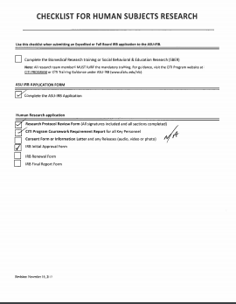
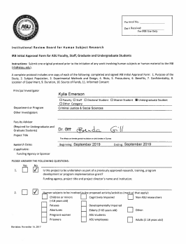

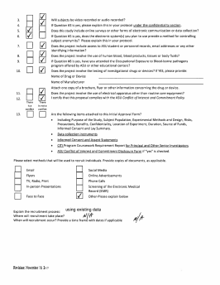

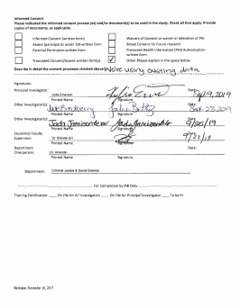
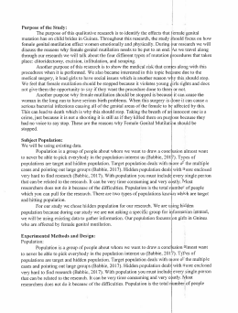

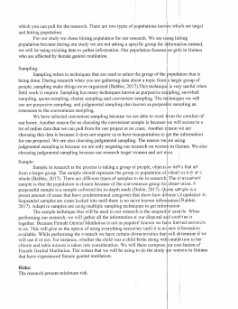

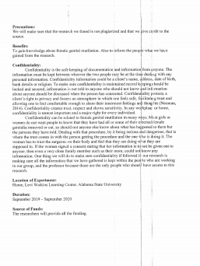

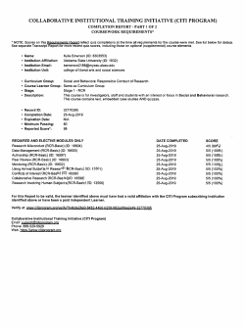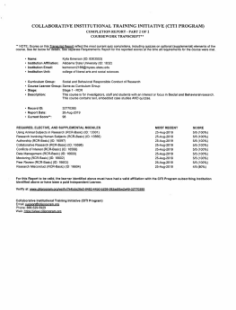

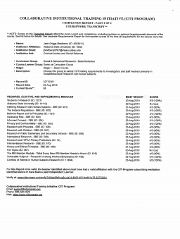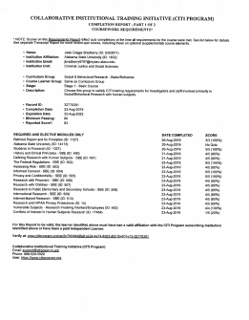

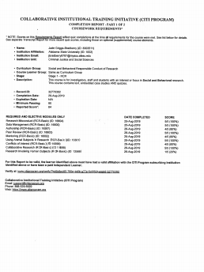
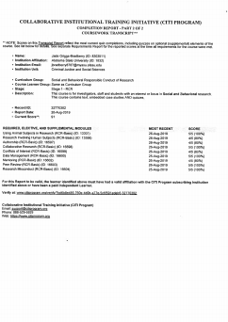

References
BABBIE, E. A. R. L. R. (2017). Basics of social research. Cengage Learning. https://ereader.chegg.com/#/books/9781305856318/cfi/93!/4/4@0.00:0.00.
Cook, P. J., & Goss, K. A. (2020). The gun debate: What everyone needs to know. Oxford, England Oxford University Press.
Cornell, S., & Florence, J. (2010). The right to bear arms in the era of the fourteenth Amendment: Gun rights or gun regulation. Santa Clara Law Digital Commons. https://digitalcommons.law.scu.edu/lawreview/vol50/iss4/1/
Gerbis, N. (2013). Can a felon own a gun in the United States? HowStuffWorks. Retrieved June 17 2020, from https://people.howstuffworks.com/can-felon-own-gun-in-united-states3.htm.
GRAMLICH, J., & SCHAEFFER, K. (2019). Seven facts about guns in the U.S. Retrieved July 11 2020, from https://www.pewresearch.org/fact-tank/2019/10/22/facts-about-guns-in-united-states/
Hodgson, J. (2017). The history and background of the Second Amendment - Gun Allegiance. Gun Allegiance. Retrieved July 9 2020, from https://www.gunallegiance.com/history-background-second-amendment/.
How can a convicted felon receive firearm rights? - JobsForFelonsHub.com. JobsForFelonsHub.com. (2020). Retrieved June 15 2020, from https://www.jobsforfelonshub.com/can-convicted-felon-receive-firearm-rights/.
Kelly, Martin. (2020, February 11). Text of the 2nd Amendment of the U.S. Constitution. Retrieved from https://www.thoughtco.com/us-constitution-2nd-amendment-text-105397
McAllister, S. R. (2011). Individual rights under a system of dual sovereignty: The right to keep and bear arms. Kansas Law Review. https://doi.org/10.17161/1808.20163
Mcnamara, J. (2017). The fight to bear arms: Challenging the Second Amendment and the U.S. Constitution as a sacred text. European Journal of American Studies, 12(2). https://doi.org/10.4000/ejas.12179
Merriam-Webster. (n.d.). Militia. In Merriam-Webster.com dictionary. Retrieved July 13, 2020, from https://www.merriam-webster.com/dictionary/militia
Merriam-Webster. (n.d.). Regulate. In Merriam-Webster.com dictionary. Retrieved July 2, 2020, from https://www.merriam-webster.com/dictionary/regulate
O’Brien, K., Lynott, D., & Daly, M. (2013, October 13). Racism, gun ownership and gun control: Biased attitudes in U.S. whites may influence policy decisions. PLOS ONE. https://journals.plos.org/plosone/article?id=10.1371%2Fjournal.pone.0077552.
Second Amendment. TheFreeDictionary.com. (, 2008). Retrieved July 2 2020, from
https://legal-dictionary.thefreedictionary.com/Second+Amendment.
Schenawolf, H. (2014). Loading and firing a brown bess musket in the Eighteenth Century. Revolutionary war journal. Retrieved June 14 2020, from http://www.revolutionarywarjournal.com/brown-bess/.
Verma, A. (2020). Watch how the world's fastest gun fires 1 million rounds per minute. Fossbytes. Retrieved June 14 2020, from https://fossbytes.com/watch-how-worlds-fastest-gun-fires-1-million-rounds-per-minute/.
1117. Restrictions on the Possession of Firearms by Individuals Convicted of a Misdemeanor Crime of Domestic Violence. Justice.gov. (, 2013). Retrieved July 17 2020, from https://www.justice.gov/archives/jm/criminal-resource-manual-1117-restrictions-possession-firearms-individuals-convicted.

Winkler, A. (2013). Gunfight: The battle over the right to bear arms in America. New York, NY: W.W. Norton & Company.
Yoo, J. (2019). Universal background checks don't violate Second Amendment | National Review. Nationalreview.com. Retrieved July 9 2020, from https://www.nationalreview.com/2019/08/universal-background-check-law-would-not-violate-second-amendment/.

